**A PROJECT REPORT**

**on**

**“ACCESS MY PHONE”**

**Submitted to**

**KIIT Deemed to be University**

**In Partial Fulfilment of the Requirement for the Award of**

**BACHELOR’S DEGREE IN**

**COMPUTER SCIENCE AND ENGINEERING**

**BY**

**ROHIT THAOSEN TARENI NAYAK DATTATRAYA DEB GOVIND YADAV**

1705262

1705280

1705304

1705310

**UNDER THE GUIDANCE OF PROF. SURESH CHANDRA MOHARANA**



**SCHOOL OF COMPUTER ENGINEERING**

**KALINGA INSTITUTE OF INDUSTRIAL TECHNOLOGY**

**BHUBANESWAR, ODISHA - 751024**

**June 2020**

KIIT Deemed to be University

School of Computer Engineering Bhubaneswar, ODISHA 751024



CERTIFICATE

This is to certify that the project entitled

“ACCESS MY PHONE“

submitted by

ROHIT THAOSEN TARENI NAYAK DATTATRAYA DEB GOVIND YADAV

1705262

1705280

1705304

1705310

is a record of bonafide work carried out by them, in the partial fulfilment of the requirement for the award of Degree of Bachelor of Engineering (Computer Science and Engineering) at KIIT Deemed to be university, Bhubaneswar. This work is done during year 2019-2020, under our guidance.

Date: / /2020

(Prof. Suresh Chandra Moharana) Project Guide

**Acknowledgements**

We are profoundly grateful to Prof. Suresh Chandra Moharana for his expert guidance and continuous encouragement throughout to see that this project rights its target since its commencement to its completion. .....................

ROHIT THAOSEN TARENI NAYAK DATTATRAYA DEB GOVIND YADAV

**ABSTRACT**

### Accessing the phone remotely permit a user to get access to his/her device remotely. This system can be accessed by any device available to your location, there is no issue whether the device has any advance feature or not, the only requirement is it must have messaging facility. The system must accept the user requirement and response immediately.

Now a days we are dependent on our mobile phones, if we forget the phone at home it seems we have lost a limb. That time we think that it would be good to access our mobile remotely, like the web browser. This application Access My Phone, instead of accessing the computer remotely, we will access the mobile phones.

This application creates a connection to the mobile phone and retrieves all the data like location, contacts and message etc.

Once the user gets all the information that he needs, then he/she can change the authenticity of his/her device.

**Contents**: -

|  |  |  |  |
| --- | --- | --- | --- |
| **Sl No.** | **Chapters** | **Page No.** | |
| **1** | Introduction | ……………………………………………………………. | 1-6 |
| ***1.1*** | *Introduction* | ……………………………………………………………. | *1* |
| ***1.2*** | *Methodology* | ……………………………………………………………. | *2-3* |
| ***1.3*** | *Purpose* | ……………………………………………………………. | *4* |
| ***1.4*** | *Risks Involved* | ……………………………………………………………. | *5* |
| ***1.5*** | *Constraints* | ……………………………………………………………. | *6* |
| ***1.6*** | *Tools Used in our Project* | ……………………………………………………………. | *6* |
| **2** | Related Works | ……………………………………………………………. | 7-8 |
| ***2.1*** | *Title 1* | ……………………………………………………………. | *7* |
| ***2.2*** | *Title 2* | ……………………………………………………………. | *8* |
| **3** | Objective | ……………………………………………………………. | 9 |
| ***3.1*** | *Objective* | ……………………………………………………………. | 9 |
| ***3.2*** | *Scope* | ……………………………………………………………. | 10 |
| ***3.3*** | *Functional Requirements* | ……………………………………………………………. | *11* |
| ***3.4*** | *Non-Functional Requirements* | ……………………………………………………………. | *12* |
| ***3.5*** | *Requirement Analysis* | ……………………………………………………………. | 13 |
| **4** | System Model | ……………………………………………………………. | 14-20 |
| ***5.1*** | *Use Case Diagram* | ……………………………………………………………. | *14* |
| ***5.2*** | *Class Activity Diagram* | ……………………………………………………………. | *15* |
| ***5.3*** | *Activity Diagram* | ……………………………………………………………. | *16* |
| ***5.4*** | *Sequence Diagram* | ……………………………………………………………. | *17* |
| ***5.5*** | *Data Flow Diagram* | ……………………………………………………………. | *18* |
| ***5.6*** | *CRC Card* | ……………………………………………………………. | *19-20* |
| ***5*** | Implementation | ……………………………………………………………. | 21-27 |
| ***8.1*** | *Set Pin* | ……………………………………………………………. | *21* |
| ***8.2*** | *Start/Stop Service* | ……………………………………………………………. | *21* |
| ***8.3*** | *Get device id* | ……………………………………………………………. | *22* |
| ***8.4*** | *Read/Retrieve contacts* | ……………………………………………………………. | *23* |
| ***8.5*** | *Generate Random Pin* | ……………………………………………………………. | *24-25* |
| ***8.6*** | *Ring and vibrate mode* | ……………………………………………………………. | *26* |
| ***8.7*** | *Lock screen remotely* | ……………………………………………………………. | *26* |
| ***8.8*** | *Send Phone location* | ……………………………………………………………. | *27* |
| **6** | System Testing (Outcome) | ……………………………………………………………. | 28-31 |
| ***6.1*** | *Set pin* | ……………………………………………………………. | *28* |
| ***6.2*** | *Get device id* | ……………………………………………………………. | *28* |
| ***6.3*** | *Retrieve contacts* | ……………………………………………………………. | *28-29* |
| ***6.4*** | *New pin* | ……………………………………………………………. | *29-30* |
| ***6.5*** | *Ring and vibrate mode* | ……………………………………………………………. | *30* |
| ***6.6*** | *Lock screen* | ……………………………………………………………. | *30-31* |
| ***6.7*** | *Getting location* | ……………………………………………………………. | *31* |
| **7** | Conclusion | ……………………………………………………………. | 32 |
| ***7.1*** | *Conclusion* | ……………………………………………………………. | *32* |
| ***7.2*** | *Future Scope* | ……………………………………………………………. | *33* |
| **8** | References | ……………………………………………………………. | 34 |
| **9** | Sample Individual Contribution Report | ……………………………………………………………. | 35-38 |
| **10** | Small-Seo Plagiarism Report | ……………………………………………………………. | 39 |

###### List Of figures: -

|  |  |  |
| --- | --- | --- |
| ***Sl. No.*** | ***List of Figures*** | ***Page No.*** |
| **1** | Iterative Waterfall Diagram | 2 |
| **2** | Use case Diagram | 14 |
| **3** | Class Diagram | 15 |
| **4** | Activity Diagram | 16 |
| **5** | Sequence Diagram | 17 |
| **6** | Data Flow Diagram | 18 |

Chapter 1

* 1. **INTRODUCTION**

With the Advent of the technologies, we have got ourselves associated with lots of new technologies and luxuries. This equipment, tools, software provides us many functionalities which helps us to reduce the burden on our daily life and make your life more easy, relaxed and swift.

For any real-world scenario, where we meet with daily life challenges, it our duty as an “Engineer” to try to mettle those challenges by developing many tools/ software which can overcome any particular issue. The Particular issue is also referred to as the Problem Statement pertaining to a Scenario or situation.

Now, in this Project too, we the 4 students of KIIT University(Batch 2017-

21) have coined our ideas around a similar type of Daily Real Life Scenario where we feel that we need to shed some light on it as such issues seem to be partially ignored but are very important for.

We have focussed mostly on the Cons of Human Lifestyle. It is none other than “Carelessness”. The term seems so simple, right? But never judge a book by it’s cover. As, we the Computer Science Engineers habit is always to meddle around an issue to bring out an extrinsic change, we also have been doing to achieve huge success by emphasizing on this.

* 1. **Methodology**

**ITERATIVE WATERFALL MODEL**

Today, in the new economy, while the possibilities for software are seemingly limitless, so is the growing demand. The problem is that speed and quality have typically been opposing forces in software development, and they still are. In the past, businesses could sacrifice software quality to respect the deadlines, or compromise on software features to meet time-to- market deadlines. In the new Internet economy, it has no choice: the software developers must produce higher quality software. So, our Project is Based upon the Iterative Waterfall Model.

**The iterative waterfall model provides feedback paths from every phase to its preceding phases, which is the main difference from the classical waterfall model.**

Feedback paths introduced by the iterative waterfall model are shown in the figure below.

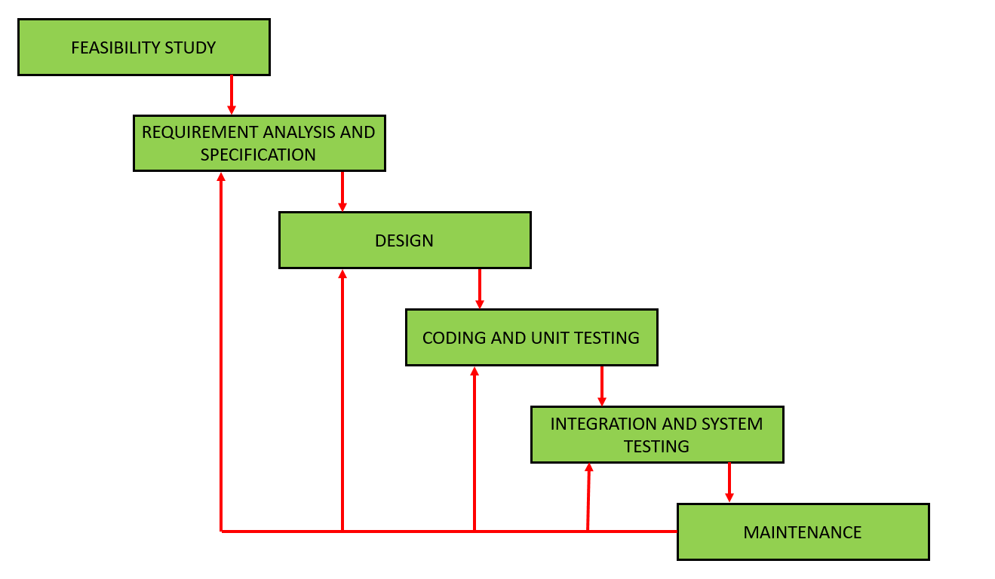

*Fig. Iterative Waterfall Model*

When errors are detected at some later phase, these feedback paths allow correcting errors committed by programmers during some phase. The feedback paths allow the phase to be reworked in which errors are committed and these changes are reflected in the later phases. But, there is no feedback path to the stage – feasibility study, because once a project has been taken, does not give up the project easily.

It is good to detect errors in the same phase in which they are committed. It reduces the effort and time required to correct the errors.

**Phase Containment of Errors:** The principle of detecting errors as close to their points of commitment as possible is known as Phase containment of errors.

**Advantages of Iterative Waterfall Model**

**Feedback Path:** In the classical waterfall model, there are no feedback paths, so there is no mechanism for error correction. But in iterative waterfall model feedback path from one phase to its preceding phase allows correcting the errors that are committed and these changes are reflected in the later phases.

**Simple:** Iterative waterfall model is very simple to understand and use. That’s why it is one of the most widely used software development models.

**Drawbacks of Iterative Waterfall Model**

**Difficult to incorporate change requests:** The major drawback of the iterative waterfall model is that all the requirements must be clearly stated before starting of the development phase. Customer may change requirements after some time but the iterative waterfall model does not leave any scope to incorporate change requests that are made after development phase starts.

**Incremental delivery not supported:** In the iterative waterfall model, the full software is completely developed and tested before delivery to the customer. There is no scope for any intermediate delivery. So, customers have to wait long for getting the software.

**Overlapping of phases not supported:** Iterative waterfall model assumes that one phase can start after completion of the previous phase, But in real projects, phases may overlap to reduce the effort and time needed to complete the project.

**Risk handling not supported:** Projects may suffer from various types of risks. But, Iterative waterfall model has no mechanism for risk handling.

**Limited customer interactions:** Customer interaction occurs at the start of the project at the time of requirement gathering and at project completion at the time of software delivery.

* 1. **Purpose**

Our Minor Project (for the 6th Semester) named as “Access My Phone” is based on the Safety and Security of our “Smart Phones”. Suppose a Phone Admin/user due to his/her carelessness loses his/her phone, then through this App, he/she can remotely retrieve the details of the device and perform necessary operations on it from other Phone without the use of “**INTERNET**”.

You might have thought that our App is very similar to “Find my Phone” by Google. But this app by Google requires Internet and has only few functions but for our App to run and send necessary details to the User operating from other phone, it doesn’t need any Internet.

We can perform many functionalities from this Application like retrieving the Device ID of phone, receiving the contacts from my Phone to the other Phone, receive my Phone GPS coordinates, Ring or Vibrate a Device, Screen Lock a Device. Well for the security purpose, we have a **PIN Authentication** which can only be accessed by the admin.

The 2 more important aspect of our Application is that **All this Operations can be performed simply through SMS with no Internet and also the App need not be installed in the Other Phone** from where I am trying to Access my Phone. See, How Simple is it, right? So much major operations can be performed through very simple procedures which even an amateur Phone user can do.

This is what we Computer Science Engineers strive for “Simplicity”, “Efficiency” and “User Friendly Lifestyle”.

* 1. **Risks Involved: -**

**Schedule Risk**

Wrong time estimation , Resources are not tracked properly, Failure to identify complex functionalities and time required to develop those functionalities, Unexpected project scope expansions.

**Budget Risk**

Wrong budget estimation, Cost overruns, Project scope expansion .

**Operational Risks**

Failure to resolve the responsibilities, Insufficient resources , No proper subject training, No resource planning, No communication in the team.

**Technical Risks**

Continuous Changing Requirements, Difficult Project modules Integration

**Programmatic Risks**

Running out of the fund, Market development, Changing customer product strategy and priority, Government rule changes.

* 1. **Constraints**

The Minimum Android Version on which this App will run is Android 8, The App must service with valid pin. If the invalid pin Enter no information will share to respective user. Pin must be set to the application in device. Detail from phone must be sent if user is authentic. Pin must be reset if detail send to unknown device.

Application get location of device. Application require device security and permission. For IMEI detail phone version should less than android version 10. Multiple User can handle this at a same time.

* 1. **Tools Used in our Project: -**

Android Development Studio, Java 8, Lucid Chart, Smart Draw, Microsoft Word, Microsoft White Board

Chapter 2

**Related Works**

**TITLE 2.1: Raspberry pi based advanced scheduling Home Automation System by Email**

**Publication**: International Journal of Advanced Research In Electronics and Communication Engineering Volume 4, Issue 9,September 2015

**Author:** MP.Satish, Dr A.S Jilani

**Description**: Advanced method of home automation of Raspberry-pi through reading the subject of Email



**Abstract**: In present days as the technology improves day by day everyone seems to automate most of the possible things to take advantage in providing ease in life, secure and saving electricity. The main objective of this paper is to develop an interactive home automation system based on raspberry-pi through reading the message body of the email which we are send. Here the message body of the received email is read by the written python programme and it will resend the acknowledgement to that email id, regarding whether the operation was successful or not. The algorithm developed in python language which the default is programming language provided by the Raspberry-pi. Store these results in internet by creating a new channel API in thing speak which is an IOT application.

*Page* ***8*** *of* ***39***

**TITLE 2.2: Advanced Control Web Based Home Automation with Raspberry-Pi**

**Publication**: International Journal of Advanced Research, Ideas and Innovation in Technology

**Author:** Prof. Dr. Ashok J Chavan, J.J Patil, P.V.K Naik, P.S Giri

**Description**: This Home automation system provides the user with the webpage of various lights and appliances within their home with the android model by webpage.

**Abstract**: The main aim of the project is to develop a system that will provide a control of home appliances by using web page when the home host not at home. Those papers are mainly concerned with the automatic control of light or any other home appliances using the internet. It is meant to save the electricity power and human energy. This project is made with the help of the raspberry-pi. For those paper of course you we used a Wi-Fi dongle. As per the request of the host a confirmation message is generate and sent through the web to the host regarding whether his or her request is fulfilled or not. The algorithm for this model is developed completely on python. This system would be really helpful in case of an emergency situation when the host is not available in the home but he needs the resources. This application can be used for many of the things that your desktop pc does. However one key aspect that makes the raspberry-pi so brilliant for school is its ability to execute Java coded programs.

.

*School of Computer Engineering, KIIT Deemed to be University, Bhubaneswar*

##### CHAPTER 3

* 1. **Objective:-**

Access My Phone is a Device Tracking and Remote Device Controlling Android Application developed on Android Studio.

It mainly focuses on helping an user to access his/her phone when it’s not in his/her nearby vicinity.

He/she can track the lcoation of the phone and perform many other necessary operation(SOS) on his/her phone remotely from another Phone. The App Solely focuses on Human Friendly Approach keeping in mind the level of Professionalism in using the Phone.

We have developed the Application on the principle of SMS or Text Message Service System and also No need of Internet.

Moreover, the App is not needed to be installed in the other Phone. The App only needs to be installed in the Phone which we are trying to Access.

Our Plan: -

The Application will have an Encrypted PIN.

If any user wants to access the phone from other phone, he/she will have to access the phone through PIN Encryption first.

The App must have the Services Started in order to carry out the important tasks.The user can send SMS from the Other Phone to the Host Phone where the App is Installed.

In the SMS, he/she will have to type simple cammands according to the requirements and send it to the Admin/ Host Phone.

The Host Phone will verify the Pin and the service status.

the App will verify the syntax of the command. The App will do the following operations: -

Sending the Device ID of the Phone.

Sending Contact Numbers(if availble) from the Host Phone to the Other Phone. Random PIN Generation, Updating it and sending it to the host Phone or to a specified Number.

Changing Host Phone to Ring or Vibrate Mode. Locking the Screen of the Phone

Send the Current GPS Coordinate of the Phone

* 1. **Scope:-**

##### There are Basically 2 Sections: -

Application Interface

From this Section, we can set the Pin, Start or Stop the Phone Service. Before that we need to give permission for the Application to the Device Administrator. There is a Help Section in the corner which has a list of all the commands to be texted to the Phone according to the operations to be performed.

**Other Phone**

The Major Operations will be performed from the Message/SMS App of the Other Phone. Here, we will be sending SMS to the phone. In the SMS , we will be typing the requird commands for certain operations. After texting the commands to the phone, the required results/outputs wil lbe received in the other Phone from the Host Phone.

If there is any error like invalid PIN, Invalid command, then, certain error messages will be received from the Other Phone.

* 1. Software Requirements & Specification (SRS)

**Functional Requirements: -**

**Set Pin**

Input : Six digit numeric pin Output :

set pin successful.

Process : To secure app data .

**Get contact detail**

Input : enter thename or fewletter of name which is storedincontact list. Output : send the contact detail of specific no.

Process : Access to contact detail.

**Get IMEIdetail**

Input : Enter for IMEIdetail Output : IMEI detail send

Process : know unique address of phone.

**Get location detail**

Input : input for location detail

Output: sendlatitudeandlongitudedetailtophone Process : know the current location of phone.

**Change phone ring/vibrate mode** Input : enter specific mode Output:phonering/vibratesetting

change

Process : Accessthering/vibrate mode

Get phone screen locked

Input : enterfor screenlocked Output: phonescreenlocked Process : phone security

## Non Functional Requirements

**Reliability**

The capability to maintain the specified level of performance is what meant by reliability, This application will run on any android phone.

**Availability: -**

The application will run 24 X 7 if internet connection is available.

**Security**:

Security requirements placed restrictions on the use of this application by the student and the faculty of Wireless Lan communicator only, control access to the data, provide different kinds of requirements to different people, require the use of passwords. It requires proper programming techniques.

**Maintainability**: -

Maintenance is one form of change that typically is done after the software development has been completed. As the time change, so do the needs. It revolves around the understanding of the existing s/w and the effects of the change. This application needs a timely updat of information table of the database by the admin. Any other feature as per the requirement can be added any time by the admin.

**Portability**

The capability adapted for different specified environments without applying actions or means other than those provided for this purpose in the product. Since, phones are portable, so do the application

# Requirement Analysis

The inputs to the process include the user’s requirements and the project constraints. The requirements are to be successfully transformed into designs within the constraints. The constraints to adhere with are devices having a minimum version of software version and the availability of network over which messages can be sent and received.

In this project, the following types of requirements are to be fulfilled:

User requirements – This includes extracting data from their device with the application installed, through another device remotely, and also making the device perform certain tasks. And the user always has to use a PIN to perform this action.

The type of data to be extracted are: Contacts, Location, Device ID

The actions to be performed by the device after receiving PIN: Set or change the PIN, change sound profile to ring/vibrate, Lock screen

Operational requirements –

The device must be running at the least Android version 8. Phone should be switched on and should be in a network coverable area.

Chapter 4

**SYSTEM MODEL**

* 1. Use Case Diagram

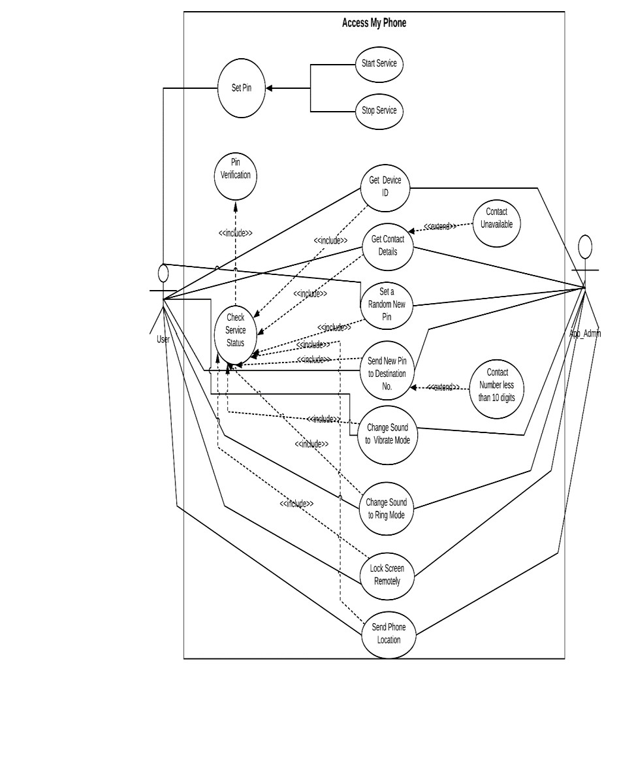

* 1. **Class Diagram**

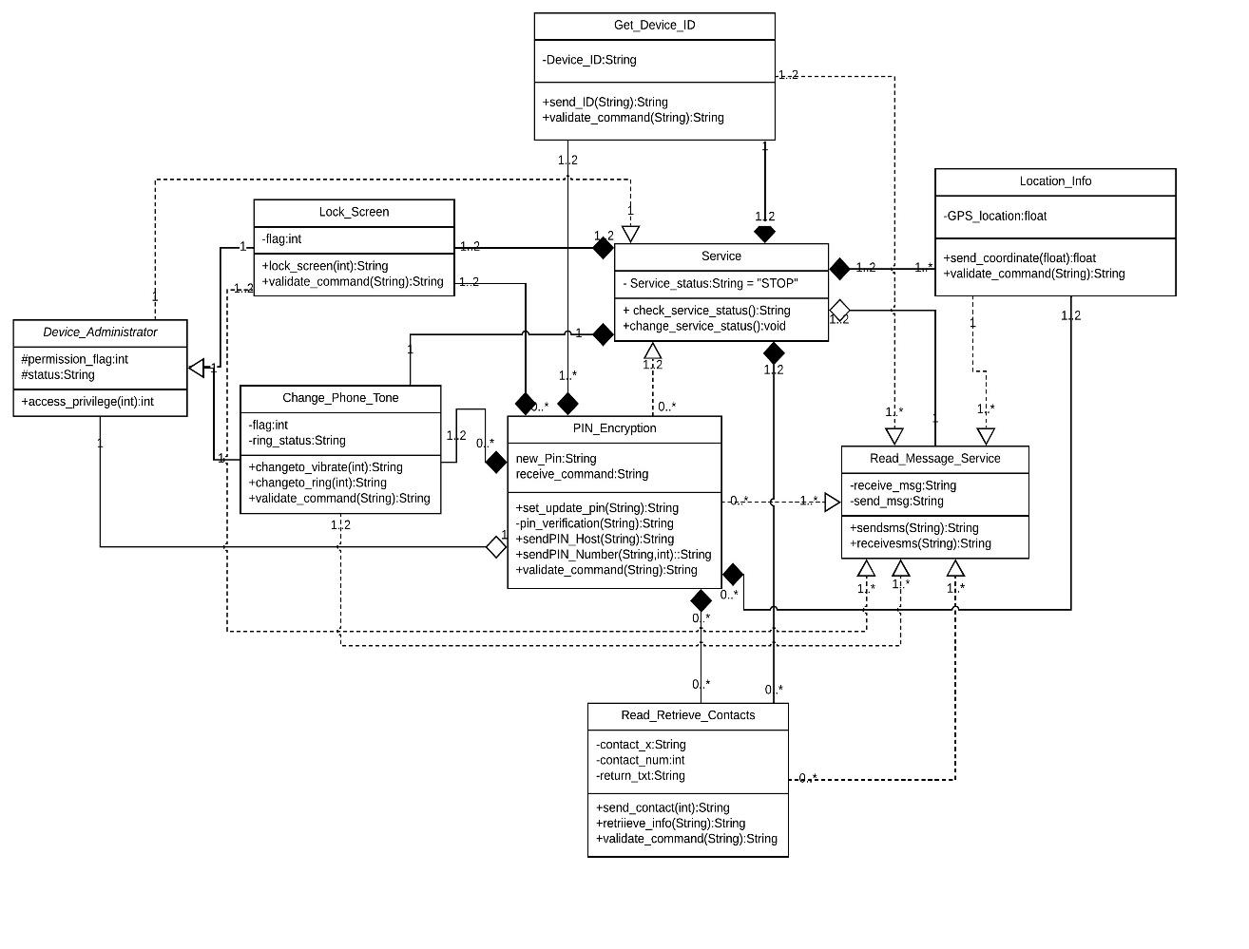

* 1. **Activity Diagram**

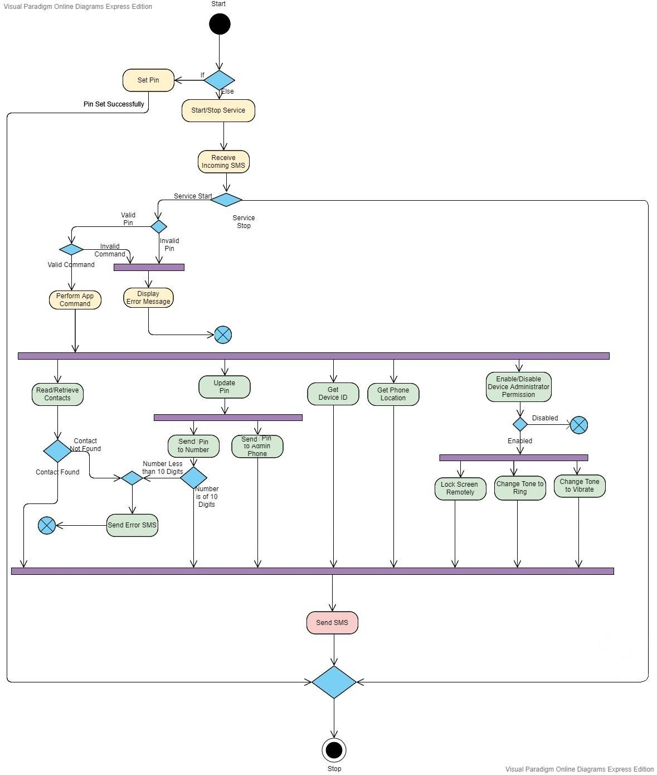

* 1. **Sequence Diagram**

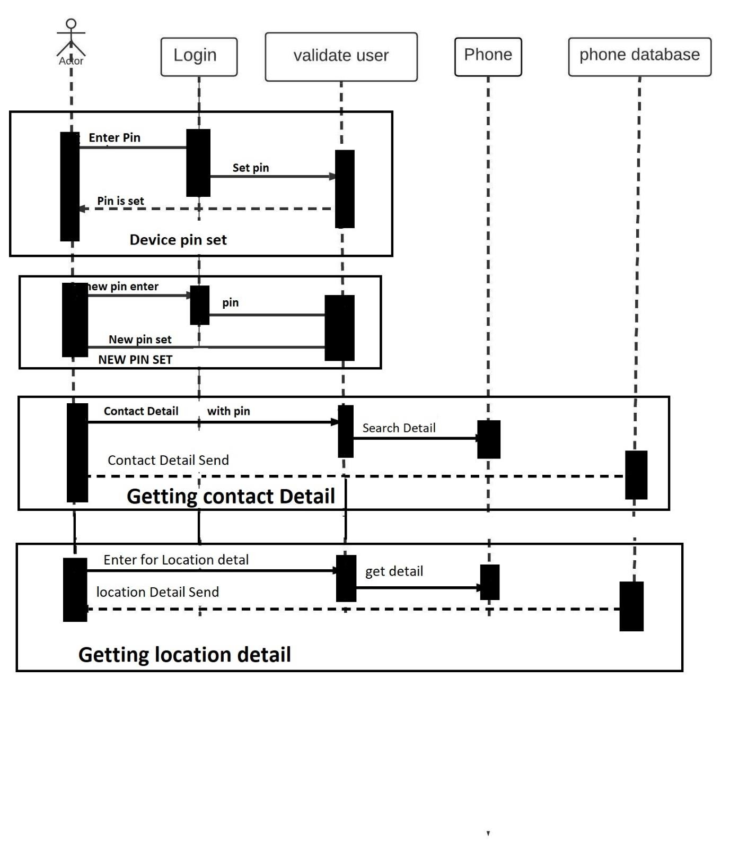

* 1. **Data Flow Diagram**

LEVEL 0-DFD : -

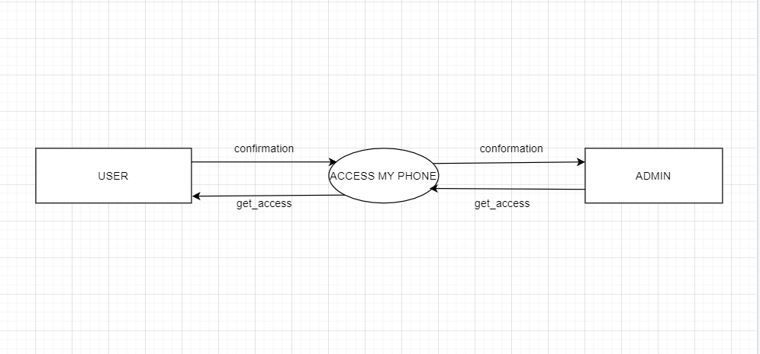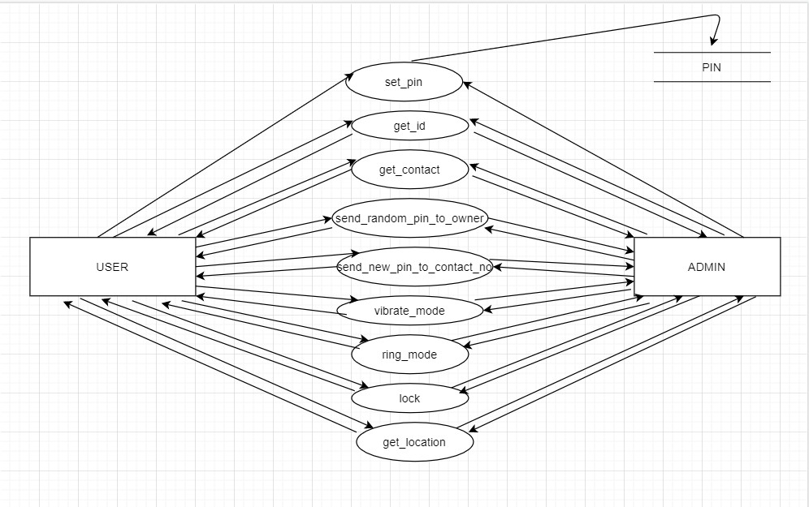

LEVEL 1-DFD :



* 1. **CRC CARD**

|  |  |  |
| --- | --- | --- |
| Class | Pin_Encryption | |
| Responsibility | | Collaboration |
| Set PIN in the App Interface | | Get_Device_ID |
| Update PIN remotely | | Device_Admin_Receiver |
| Pin Verification | | Location_Info |
| Send Random New Pin to Host Phone | | Read_Retrieve_Contacts |
| Send Random New Pin to a Number | | Lock_Screen |
| Validate Incoming Command | | Change_Phone_Tone |
|  | | Service |

|  |  |  |
| --- | --- | --- |
| Class | Service | |
| Responsibility | | Collaboration |
| Start or Stop the Application Service. | | Get_Device_ID |
| Check the Current Service Status. | | Device_Administrator |
| Send the current service status to other | | Location_Info |
| Classes | | Read_Retrieve_Contacts |
|  | | Lock_Screen |
|  | | Change_Phone_Tone |
|  | | Pin_Encryption |

|  |  |
| --- | --- |
| Class Read_Message_Service | |
| Responsibility | Collaboration |
| Send SMS as expected result from the Host | Pin_Encryption |
| Phone according to the valid Commands | Get_Device_ID |
| input | Device_Administrator |
| Receive SMS as the commands from the | Lock_Screen |
| other Phone. | Change_Phone_Tone |
|  | Read_Retrieve_Contacts |
|  | Location_Info |

|  |  |
| --- | --- |
| Class Read_Retrieve_Contacts | |
| Responsibility | Collaboration |
| Check Availability of Contact name starting with a character or multiple lines of character as input through Command from the Remote Phone.  Validate Incoming Command  Send the Contact Information if found.  Send Not Available to the Remote Phone if Contact is Found | Read Message Service Service Pin_Encryption |

|  |  |
| --- | --- |
| Class *Device_Administrator* | |
| Responsibility | Collaboration |
| Retrieve Status Service | Service |
| Enable or Disable the Access privileges to | Lock_Screen |
| the Application for the Lock Screen Class | Change_Phone_Tone |
| and Change_Phone_Tone Class. | Pin_Encryption |
| Super Class of Lock_Screen and |  |
| Change_Phone_Tone Class |  |



|  |  |
| --- | --- |
| Class Lock_Screen | |
| Responsibility | Collaboration |
| Lock Screen Remotely  Validate the Incoming Command | Device_Administrator Service Pin_Encryption  Read_Message_Service |

|  |  |
| --- | --- |
| Class Change_Phone_Tone | |
| Responsibility | Collaboration |
| Change phone to Ring Mode Change phone to Vibrate Mode Validate the Incoming Command | Device_Administrator Service Pin_Encryption  Read_Message_Service |

|  |  |
| --- | --- |
| Class Get_Device_ID | |
| Responsibility | Collaboration |
| Send the Device ID  Validate the Incoming Command | Service Pin_Encryption  Read_Message_Service |

|  |  |
| --- | --- |
| Class Location_Info | |
| Responsibility | Collaboration |
| Send Current or Last recorded GPS Coordinates  Validate the Incoming Command | Service Pin_Encryption  Read_Message_Service |

Chapter 5

* 1. Set Pin

**SOFTWARE IMPLEMENTATION**

* 1. **Start/Stop Service**

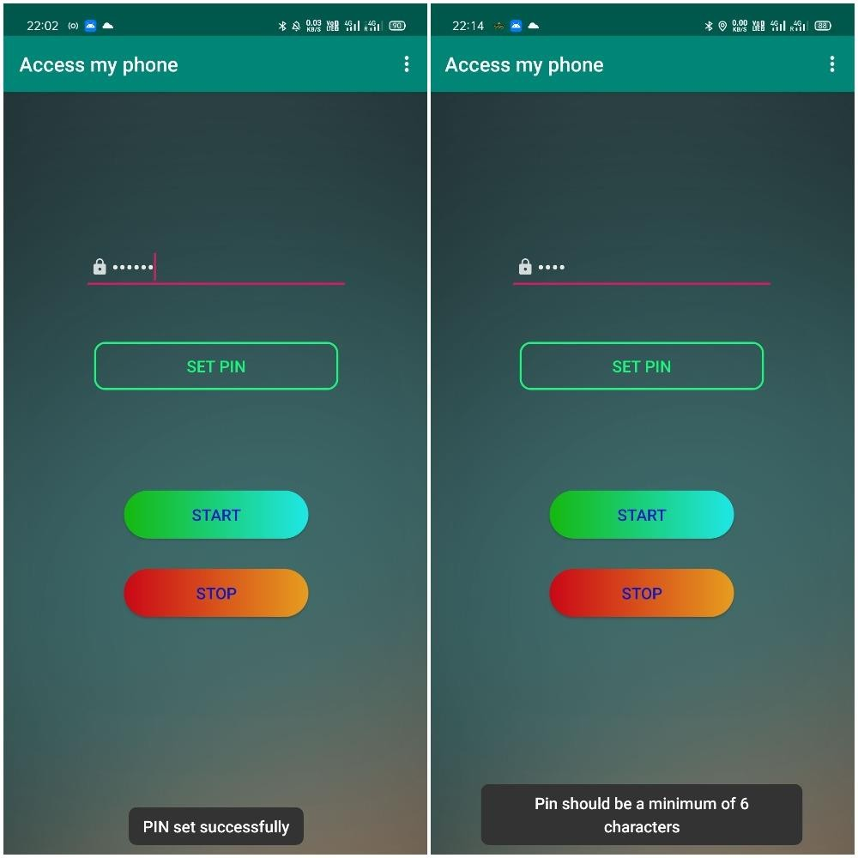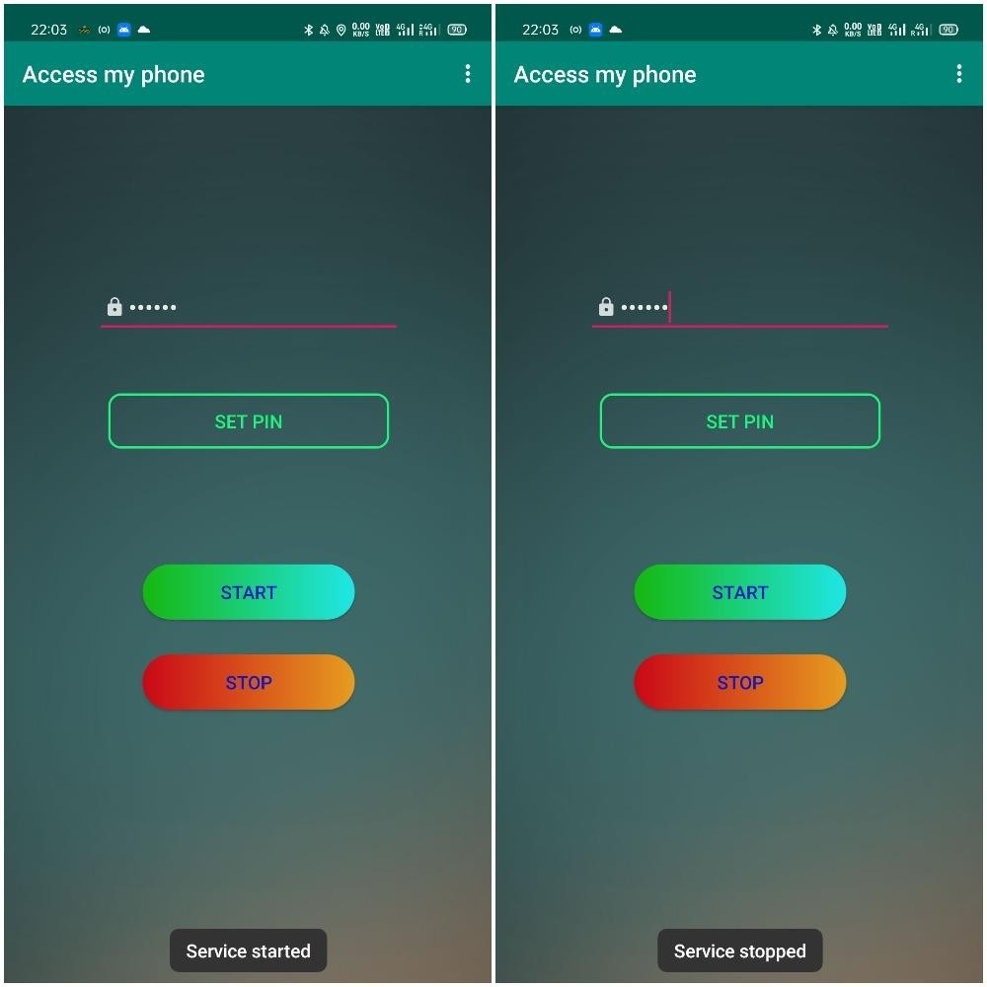

* 1. **Get Device ID: - <pin> get id**

*Top Photo: - SMS sent to my phone from Other Phone and Device ID got retrieved*

*Bottom Photo: - SMS received in my Phone from the other phone where the App is “On” and the Device ID got sent to the other Phone*.

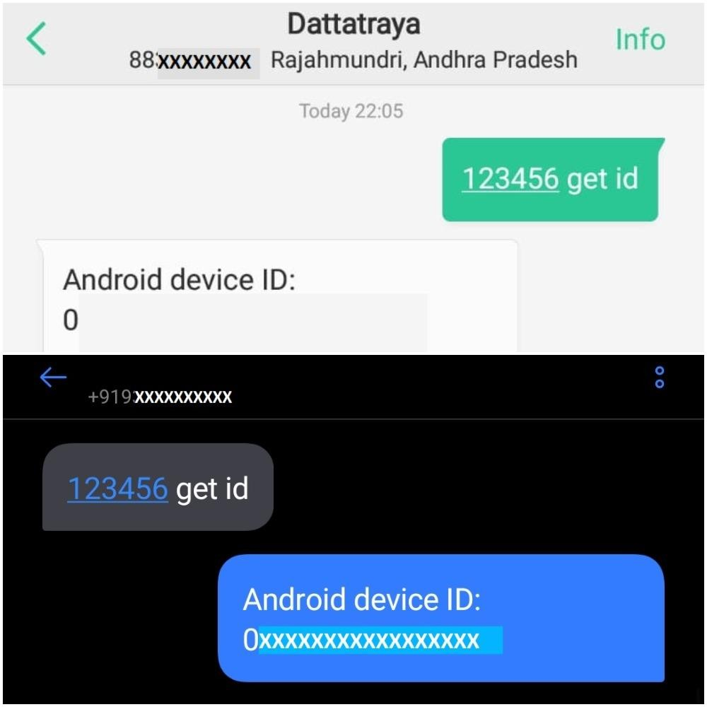

* 1. Read/Retrieve Contacts (Sending Required Contact from Host Phone to Other Phone): -<pin> contact X

*Top Photo: - SMS sent to my phone from Other Phone and Contacts starting with a letter say ‘W’ got retrieved*

*Bottom Photo: - SMS received in my Phone from the other phone where the App is “On” and the requested Contact starting with ‘W’ got sent to the other Phone*.

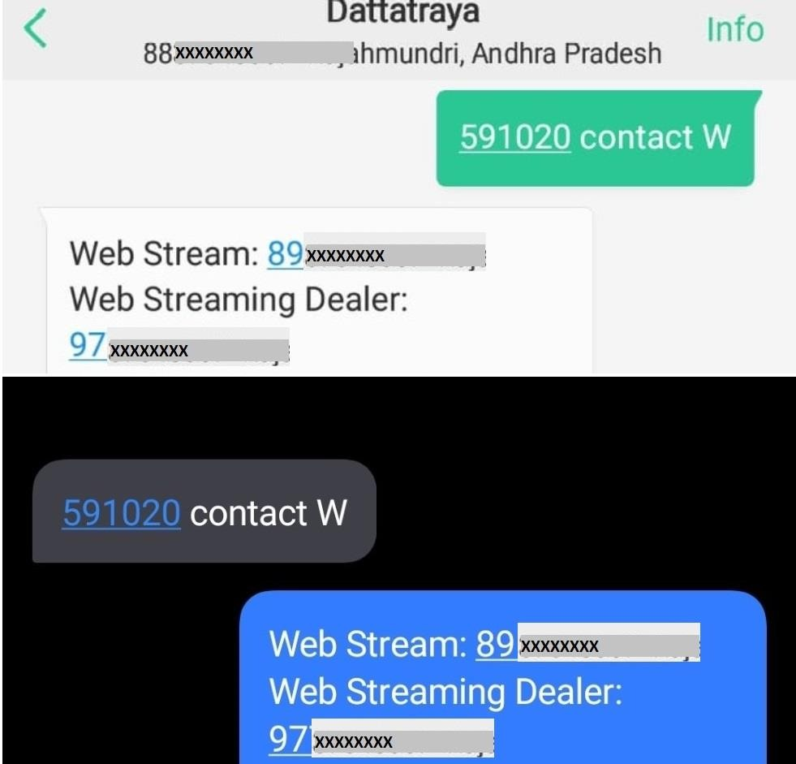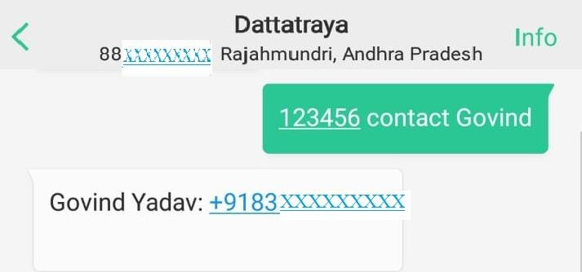

*Here is another Example depicting Implementation of the above stated command: -*

* 1. Generate Random Pin: - <pin> pass

1. New Pin Sent to Admin (Host Phone)

*Top Photo: - SMS sent to my phone from Other Phone and new Random pin was generated and updated and thereafter the New pin was sent as an SMS to my Phone (Admin/Host Phone) Middle Photo: - SMS received in my Phone from the other phone where the App is “On” and an Affirmation regarding the Successful Pin Update/Change was sent to the Other Phone.*

*Bottom Photo:- New Pin Received in the Admin Phone*

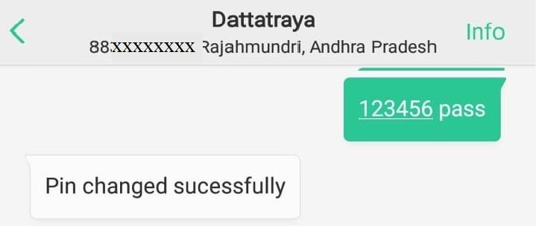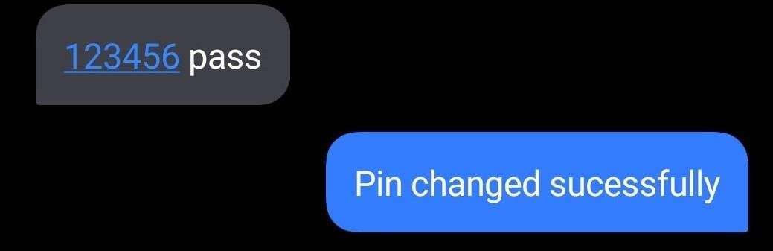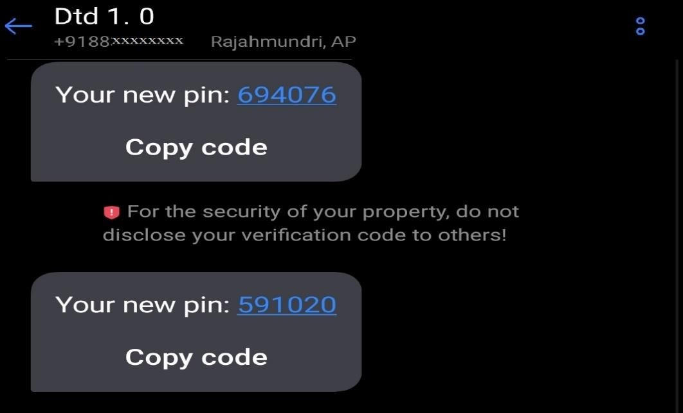

1. New Pin Sent to Other Number: <pin> pass <contact_number>

*Top Photo: - SMS for random new pin generation and sending it to a number was sent to my phone from Other Phone and new Random pin was generated and updated and thereafter the New pin was sent to another Number as specified in the incoming SMS from the other Phone. Middle Photo: - SMS received in my Phone from the other phone where the App is “On” and an Affirmation regarding the Successful Pin Update/Change and thereafter being sent to other number was sent to the Other Phone.*

*Bottom Photo: - New pin received to Another Number.*

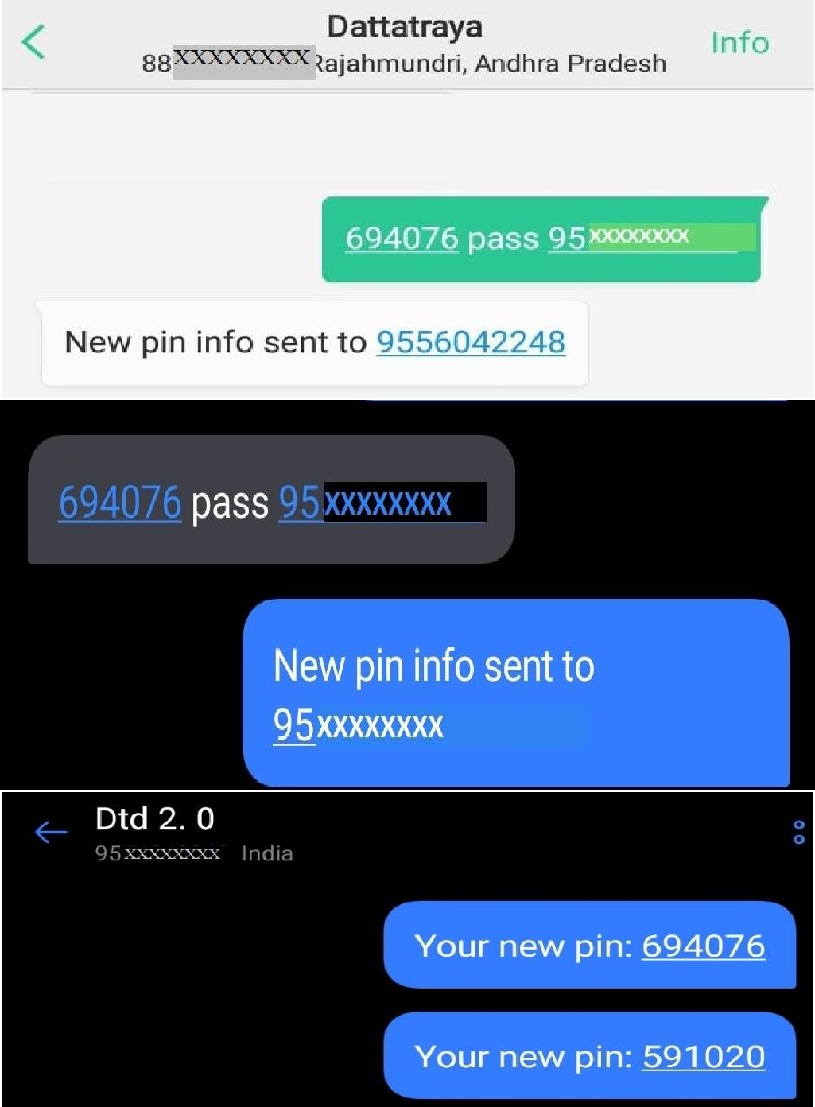

* 1. Ring/Vibrate: - i) <pin> vibrate, ii) <pin> ring

*Top Photo: - SMS sent to my phone from Other Phone and Device ID got retrieved Bottom Photo: - SMS received in my Phone from the other phone where the App is “On” and the Device ID got sent to the other Phone.*

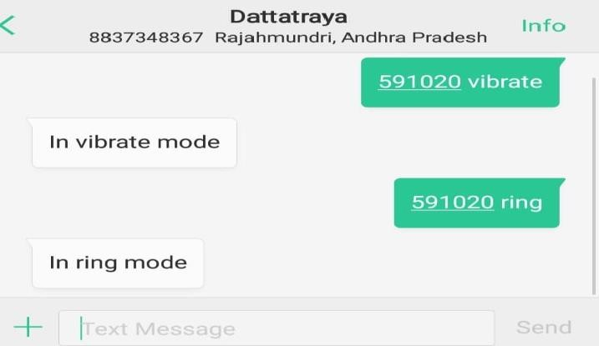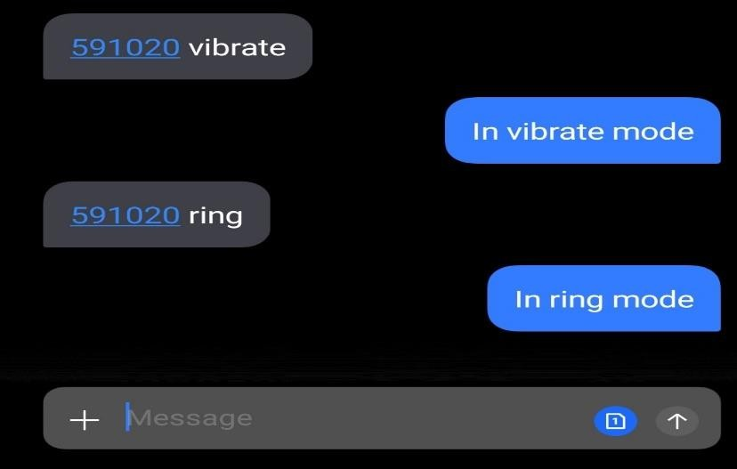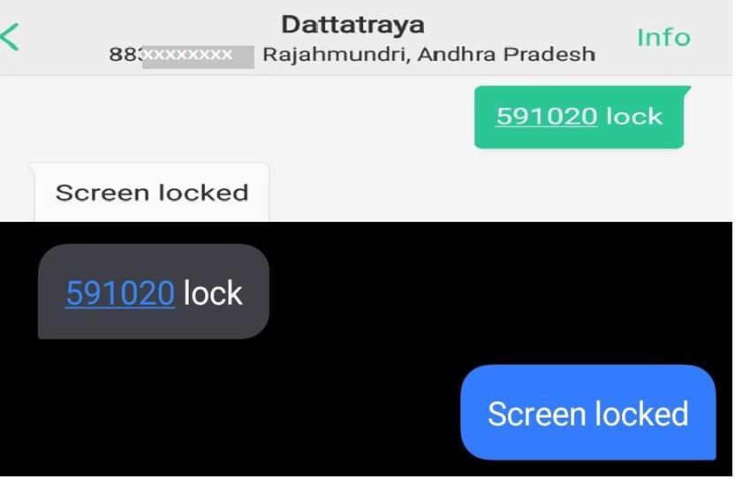

* 1. Lock Screen Remotely: - <pin> lock

*Top Photo: - SMS sent to my phone from Other Phone and my phone Screen got Locked Bottom Photo: - SMS received in my Phone from the other phone where the App is “On” and my device sent an affirmation confirming the Screen Lock.*

* 1. Send Phone Location: - <pin> location

*Top Photo: - SMS sent to my phone from Other Phone and Admin/Host Phone Location (GPS Coordinates) got retrieved*

*Bottom Photo: - SMS received in my Phone from the other phone where the App is “On” and the Phone Location(GPS Coordinates) got sent to the other phone from where Phone Location was requested*.

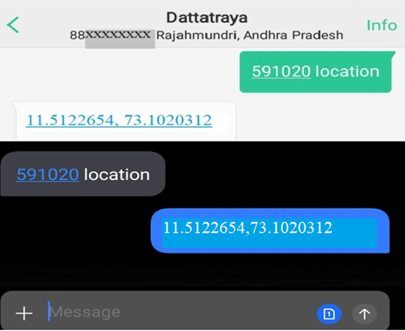

Chapter 6

SYSTEM TESTING (OUTCOME)

* 1. **TEST CASE FOR SET PIN**

|  |  |  |  |  |  |
| --- | --- | --- | --- | --- | --- |
| Test Case  ID | Test Case Name | Test Case Procedure | Pre Condition | Expected Result | |
| Success | Failure |
| T01 | Set Pin: 123456 | Enter any pin containing alphanumeric characters. | NULL | Pin Set Successfully | Nil |
| T03 | Set Pin: ab12e34fg | Enter any pin containing alphanumeric characters. | NULL | Pin Set Successfully | Nil |
| T02 | Set Pin: | Do | NULL | Nil | Pin |
|  | Abe1 |  |  |  | Should be |
|  |  |  |  |  | a |
|  |  |  |  |  | minimum |
|  |  |  |  |  | of 6 |
|  |  |  |  |  | characters |

* 1. **TEST CASE FOR GET DEVICE ID**

|  |  |  |  |  |  |
| --- | --- | --- | --- | --- | --- |
| Test Case  ID | Test Case Name | Test Case Procedure | Pre Condition | Expected Result | |
| Success | Failure |
| T01 | 123456  get id | In the message Box, send SMS to the host phone by typing the Pin of the host phone, then type” get id” to retrieve the Unique Device ID. The Command Syntax is:  <PIN> get id | Service must be “Started”.  Pin Set in Host Phone as 123456  for the Sample Test Cases | Android device ID: 0003abccdddefgg56 | Nil |
| T02 | 123456  getid | Do | Do | Nil | Invalid Command |
| T03 | 12345 get id | Do | Do | Nil | No Response as PIN is wrong |

* 1. **TEST CASE FOR RETRIEVING CONTACTS**

|  |  |  |  |  |  |
| --- | --- | --- | --- | --- | --- |
| Test Case  ID | Test Case Name | Test Case Procedure | Pre Condition | Expected Result | |
| Success | Failure |
| T01 | 123456 | From another phone, by | Service | Govind Yadav: | Nil |
|  | contact | sending SMS to the host | Must be | +91xxxxxxxxxx |  |
|  | Govind | phone, this Command | Started. |  |  |
|  |  | sends the contact details | Pin Set in |  |  |
|  |  | of a person (if available) | Host |  |  |
|  |  | from the Host Phone. | Phone as |  |  |
|  |  | Syntax: <pin> contact | 123456 |  |  |
|  |  | <contact name> | for the |  |  |
|  |  |  | Sample |  |  |

|  |  |  |  |  |  |
| --- | --- | --- | --- | --- | --- |
|  |  |  | Test Cases |  |  |
| T02 | 123456  contact XYZ | Do | Do | Nil | Contact not found |
| T03 | 123456  contactXYZ | Do | Do | Nil | invalid Command |
| T04 | 123456 | From another phone, by | Do | Ashu:+91xxxxxxxxxx | Nil |
|  | contact A | sending SMS to the host |  | Anuj: |  |
|  |  | phone, this Command |  | +91xxxxxxxxxx |  |
|  |  | sends the contact details |  | Ajay:+91xxxxxxxxxx |  |
|  |  | of a person (if available) |  |  |  |
|  |  | from the Host Phone. |  |  |  |
|  |  | Syntax: <pin> contact |  |  |  |
|  |  | <X> |  |  |  |
|  |  | Here, ‘X’ means contact |  |  |  |
|  |  | Number of those people |  |  |  |
|  |  | will be sent whose |  |  |  |
|  |  | Contact name starts with |  |  |  |
|  |  | X. |  |  |  |
|  |  | In Place of X , there can |  |  |  |
|  |  | be single character for |  |  |  |
|  |  | multiple characters |  |  |  |
| T05 | 123456 | Do | Do | Abhishek: | Nil |
|  | contact Ab |  |  | +91xxxxxxxxxx |  |
|  |  |  |  | Abantika: |  |
|  |  |  |  | +91xxxxxxxxxx |  |

* 1. **TEST CASES FOR NEW PIN**

|  |  |  |  |  |  |
| --- | --- | --- | --- | --- | --- |
| Test Case  ID | Test Case Name | Test Case Procedure | Pre Condition | Expected Result | |
| Success | Failure |
| T01 | 123456 pass | From another phone, by sending SMS to the host phone, this Command sends the newly generated Random Pin from the sender phone to the Host Phone.  Syntax:  <pin> pass | Service must be started.  Pin Set in Host Phone as 123456  for the Sample Test Cases. | In the Sender’s Phone:Pin changed Successfully.  In the Host Phone: Your new pin:54xxxx | Nil |
| T02 | 123456passs | Do | Do | Nil | Invalid  command |
| T03 | 123456 pass 9436xxxxxx | From another phone, by sending SMS to the host phone, this Command sends the newly generated Random Pin from the sender phone to a selected | Do | In the sender’s phone: New Pin info sent to 9436xxxxxx  In the receiver’s phone: Your new  pin:56xxxx | Null |

|  |  |  |  |  |  |
| --- | --- | --- | --- | --- | --- |
|  |  | trustworthy contact.  Syntax:  <pin> pass  <contact no.> |  |  |  |
| T04 | 123456 pass  94365 | Do | Do | Nil | 94365 is  not a valid contact no. |
| T04 | 123456 pass  *&/ | Do | DO | Nil | *&/ is not a valid  contact no. |

* 1. **TEST CASES FOR RING AND VIBRATE MODE**

|  |  |  |  |  |  |
| --- | --- | --- | --- | --- | --- |
| Test Case  ID | Test Case Name | Test Case Procedure | Pre Condition | Expected Result | |
| Success | Failure |
| T01 | 123456 ring | From another phone, by sending SMS to the host phone, this Command enables the ring mode in the Host Phone.  Syntax: <pin> ring | Service Must be started  Pin Set in Host Phone as 123456  for the Sample Test Cases | It will display the message of “In Ring Mode” and the host phone will be in Ring Mode | Nil |
| T02 | 123456 rings | Do | Do | Nil | Invalid command |
| T03 | 123456  vibrate | From another phone, by sending SMS to the host phone, this Command enables the vibration mode in the Host Phone.  Syntax: <pin> vibrate | Service Must be started  Pin Set in Host Phone as 123456  for the Sample  Test Cases | It will display the message of “In Vibrate Mode” and the host phone will be in Vibrate Mode | Nil |
| T04 | 123456vibrate | Do | Do | Nil | Invalid Command |
| T05 | 123 vibrate | Do | Do | Nil | No Response as PIN is wrong |

* 1. **TESTCASES FOR LOCK SCREEN**

|  |  |  |  |  |  |
| --- | --- | --- | --- | --- | --- |
| Test  Case ID | Test Case Name | Test Case Procedure | Pre Condition | Expected Result | |
| Success | Failure |
| T01 | 123456 lock | From another phone, by sending SMS to the host phone, this Command will lock the Host’s phone.  Syntax: <pin> lock | Service Must be started Pin Set in Host Phone as  123456 | It will display the message of “Screen Locked” and the host  phone screen | Nil |

|  |  |  |  |  |  |
| --- | --- | --- | --- | --- | --- |
|  |  |  | for the Sample Test Cases | will be locked immideiately |  |
| T02 | 123456  locked | Do | Do | Nil | Invalid command |
| T03 | 1234lock | Do | Do | Nil | Invalid Command |
| T04 | 123 lock | Do | Do | Nil | No Response as PIN is wrong |

* 1. **TEST CASES FOR GETTING LOCATION**



|  |  |  |  |  |  |
| --- | --- | --- | --- | --- | --- |
| Test  Case ID | Test Case Name | Test Case Procedure | Pre Condition | Expected Result | |
| Success | Failure |
| T01 | 123456  location | From another phone, by sending SMS to the host phone, this Command will give the location of the Host’s phone.  Syntax: <pin> location | Service Must be started  Pin Set in Host Phone as 123456  for the Sample Test  Cases | It will display the current location of the host phone.  Eg: 20.812641,65.2695812 | Nil |
| T02 | 123456  getlocation | Do | Do | Nil | Invalid command |
| T04 | 123 location | Do | Do | Nil | No Response as PIN is wrong |

# Chapter 7

#### Conclusion

Phone Tracking and Remote Phone Access Applications are recently rising in Demand now-a days.

It mainly focuses on the safety, security and tracking of Devices.

During times of emergency, we can perform emergency operations remotely from the phone.

This Application can be mainly used by Police Department for Tracking and other Investigation purposes.

Such Applications can save an user’s huge loss of money and sensitive data if he/she gets back access to the Device Again.

Even this app can be a good example for Monitoring system if you don’t have the Device in your nearby vicinity.

This Application is basically a Minor Project made by 4 students under a project Guide from KIIT Deemed to be University, Bhubaneswar for the 6th Semester.

Such Development of Applications are especially focussed on making Human Lifestyle more flexible, efficient and less Effort.

We as Engineers always keeps up the priority to take on such Projects which emphasizes on Eradication of Daily Real Life Problems and thereby take a great step in improving the quality of Human Lifestyle.

* 1. **Future Scope**

We will try to use this app sooner in Smart Watches, Tablets and Other Devices. It can serve us a good tracking Application for the Police Dept.

We will try to add a GPS timer which will send timely device coordinates in certain time intervals.

We will add further more security to the Application like Master Password, Fingerprint Authentication, etc.

We are also focusing to add more functionality in this Application like Disabling/Enabling certain features.

We are also looking forward to add more security applications to it in the future.

Chapter 8

**References**

* + 1. Narender, M., and M. Vijayalakshmi. "Raspberry Pi based advanced scheduled home automation system through E-mail." In 2014 IEEE International Conference on Computational Intelligence and Computing Research, pp. 1-4. IEEE, 2014.
    2. Chavan, J. J., P. V. Patil, and P. S. Naik. "Advanced control web based home automation with Raspberry Pi." International Journal of Advanced Research, Ideas and Innovation in Technology(2017).
    3. [www.youtube.com](http://www.youtube.com/)
    4. [https://www.geeksforgeeks.org/myhelper-access-phone-anywhere- without-internet/](https://www.geeksforgeeks.org/myhelper-access-phone-anywhere-%20%20%20without-internet/)



**SAMPLE INDIVIDUAL CONTRIBUTION REPORT:**

**ACCESS MY PHONE**

ROHIT THAOSEN 1705262

**Abstract:** Accessing the phone remotely permit a user to get access to his/her device remotely. This system can be accessed by any device available to your location, there is no issue whether the device has any advance feature or not, the only requirement is it must have messaging facility. The system must accept the user requirement and response immediately. Now a days we are dependent on our mobile phones, if we forget the phone at home it seems we have lost a limb. That time we think that it would be good to access our mobile remotely, like the web browser. This application Access My Phone, instead of accessing the computer remotely, we will access the mobile phones. This application creates a connection to the mobile phone and retrieves all the data like location, contacts and message etc.

Once the user gets all the information that he needs, then he/she can change the authenticity of his/her device.



**Individual contribution and findings:** Ideation, Application Development(Coding) and initial testing of the application, Debugging.

**Individual contribution to project report preparation:** Requirement Analysis section of the report and code snippets.

**Individual contribution for project presentation and demonstration:** Code snippets and explanation of the code implementation.

Full Signature of Supervisor:

Full signature of the student:

………………………………………

**ACCESS MY PHONE**

Tareni Nayak 1705280

**Abstract:** Accessing the phone remotely permit a user to get access to his/her device remotely. This system can be accessed by any device available to your location, there is no issue whether the device has any advance feature or not, the only requirement is it must have messaging facility. The system must accept the user requirement and response immediately. Now a days we are dependent on our mobile phones, if we forget the phone at home it seems we have lost a limb. That time we think that it would be good to access our mobile remotely, like the web browser. This application Access My Phone, instead of accessing the computer remotely, we will access the mobile phones. This application creates a connection to the mobile phone and retrieves all the data like location, contacts and message etc.

Once the user gets all the information that he needs, then he/she can change the authenticity of his/her device.



**Individual contribution and findings:** Ideation, Related Works, UML Data Flow Diagram, System Testing, Implementation

**Individual contribution to project report preparation:** Literature Survey, Plagiarism Report, Data Flow Diagram, System Testing, System Testing, Implementation

**Individual contribution for project presentation and demonstration:**

Conclusion, Future Scope, Objective, Purpose

Full Signature of Supervisor:

Full signature of the Student:

……………………………………….

DATTATTRAYA DEB 1705304

**Abstract:** Accessing the phone remotely permit a user to get access to his/her device remotely. This system can be accessed by any device available to your location, there is no issue whether the device has any advance feature or not, the only requirement is it must have messaging facility. The system must accept the user requirement and response immediately. Now a days we are dependent on our mobile phones, if we forget the phone at home it seems we have lost a limb. That time we think that it would be good to access our mobile remotely, like the web browser. This application Access My Phone, instead of accessing the computer remotely, we will access the mobile phones. This application creates a connection to the mobile phone and retrieves all the data like location, contacts and message etc.

Once the user gets all the information that he needs, then he/she can change the authenticity of his/her device.



**Individual contribution and findings:** Ideation, System Design, Software Testing, Implementation

**Individual contribution to project report preparation:** System Design-UML Diagrams, CRC Card, Project Introduction, Risk Analysis, System Testing, Implementation, Project Planning, Conclusion, Future Scope, References.

**Individual contribution for project presentation and demonstration:** Project Planning, Introduction and Future Scope

Full Signature of Supervisor:

Full signature of the student:

……………………………………….

GOVIND YADAV 1705310

**Abstract:** Accessing the phone remotely permit a user to get access to his/her device remotely. This system can be accessed by any device available to your location, there is no issue whether the device has any advance feature or not, the only requirement is it must have messaging facility. The system must accept the user requirement and response immediately. Now a days we are dependent on our mobile phones, if we forget the phone at home it seems we have lost a limb. That time we think that it would be good to access our mobile remotely, like the web browser. This application Access My Phone, instead of accessing the computer remotely, we will access the mobile phones. This application creates a connection to the mobile phone and retrieves all the data like location, contacts and message etc.

Once the user gets all the information that he needs, then he/she can change the authenticity of his/her device.

**Individual contribution and findings:** Ideation, Software Requirement and Specification, Abstract, Sequence Diagram, Methodology, Implementation



**Individual contribution to project report preparation:** SRS, Sequence Diagram, Future Scope

**Individual contribution for project presentation and demonstration:** Code snippets and explanation of the code implementation.

Full Signature of Supervisor: Full signature of the student:

……………………………………….

**SMALL-SEO PALAGRISM RESULT**

